QUESTION 1

Define database and schema and their types.

**❖ Database:**

* A database is a structured collection of data that is organized and stored for efficient retrieval, management, and manipulation.
* It serves as a central repository for storing data that can be accessed, updated, and queried by software applications.
* Databases are used to store various types of information, ranging from business data and customer records to scientific research data and more.
* Databases are essential in modern computing and are commonly used in applications such as websites, mobile apps, enterprise systems, and data analysis tools.
* There are different types of databases based on their data models and structures.

Relational Database Management System (RDBMS):

NoSQL Databases:

**❖ Schema:**

* A schema, in the context of a database, defines the structure and organization of the data within that database. It specifies how the data is organized into tables, the relationships between tables, the constraints applied to the data, and the rules for accessing and manipulating the data. In essence, a schema acts as a blueprint for the database, providing a formal definition of its structure.There are two main types of schemas:

**Physical Schema:**

* The physical schema defines how data is stored on the physical storage devices, such as hard drives or solid-state drives. It includes details like file organization, indexing methods, and data storage optimization techniques. The physical schema is concerned with performance optimization and storage considerations.

**Logical Schema:**

* The logical schema defines the structure of the data as seen by the users and the application programs. It abstracts away the physical storage details.The logical schema includes the definition of tables, columns, relationships, constraints, and security permissions.

QUESTION 2

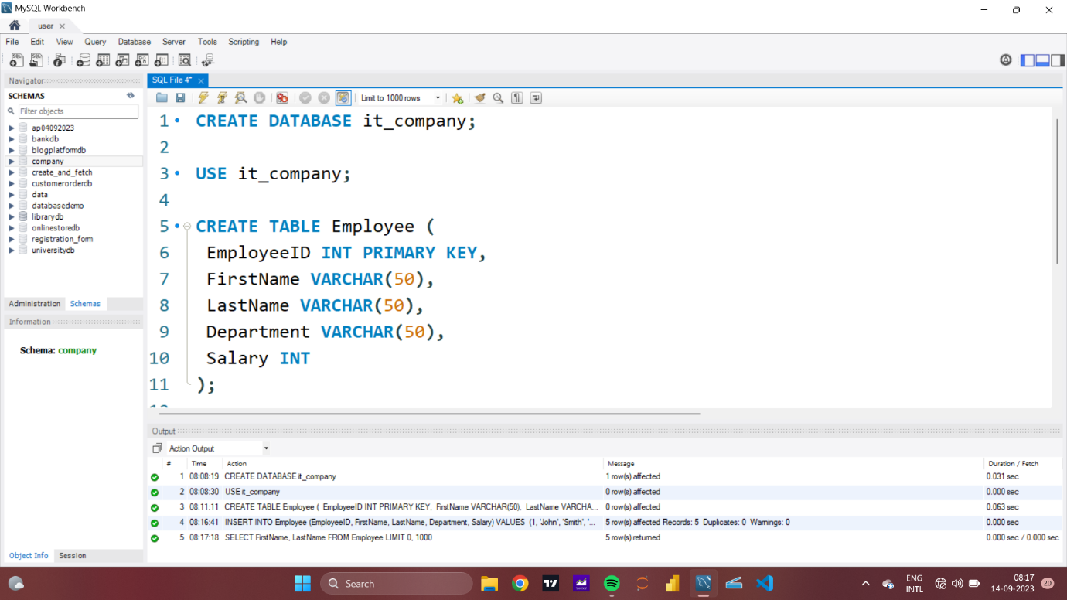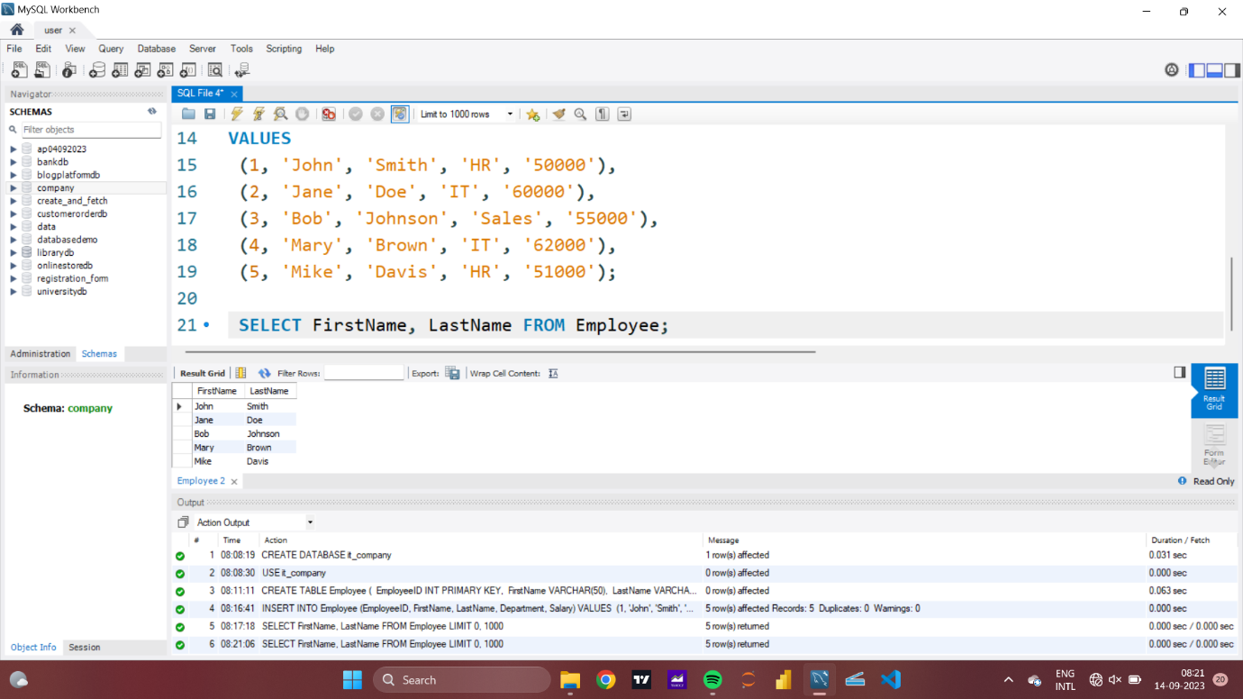

QUESTION 3

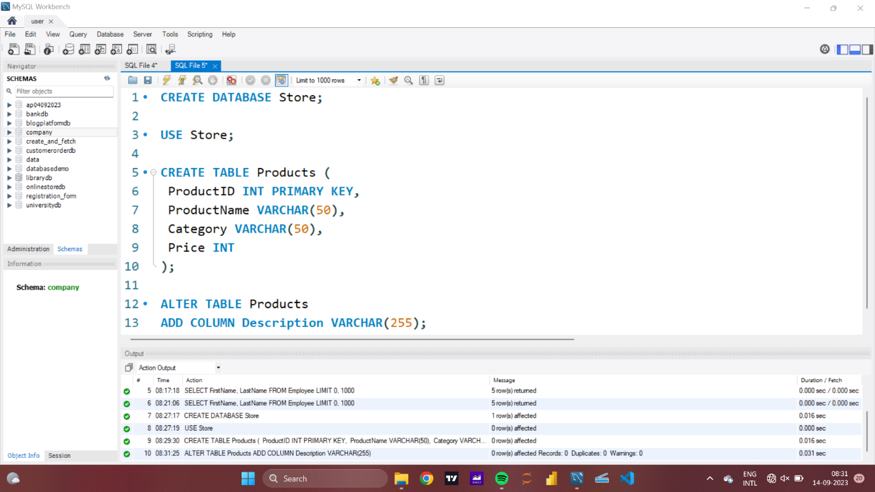

QUESTION 4

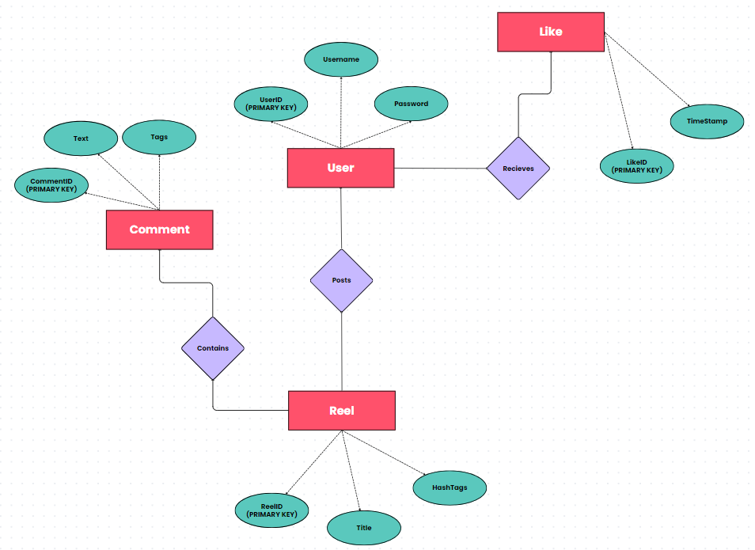

QUESTION 6

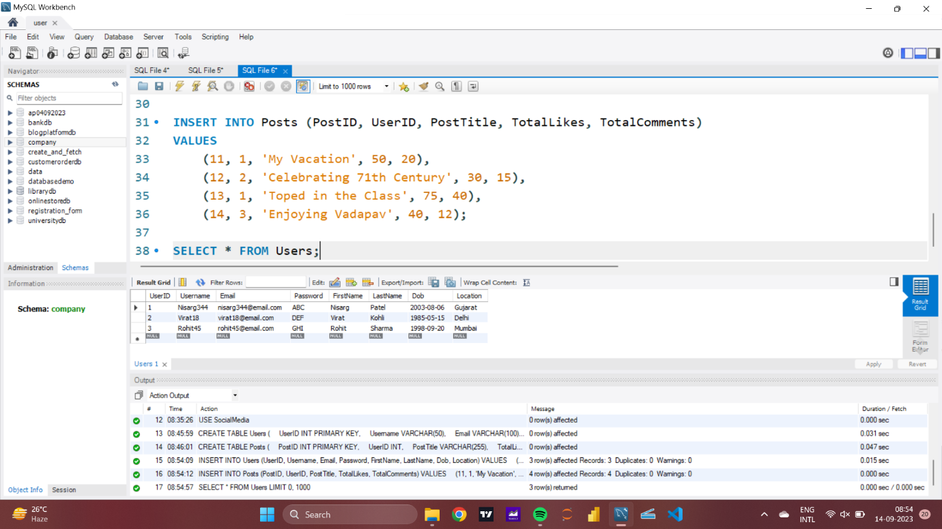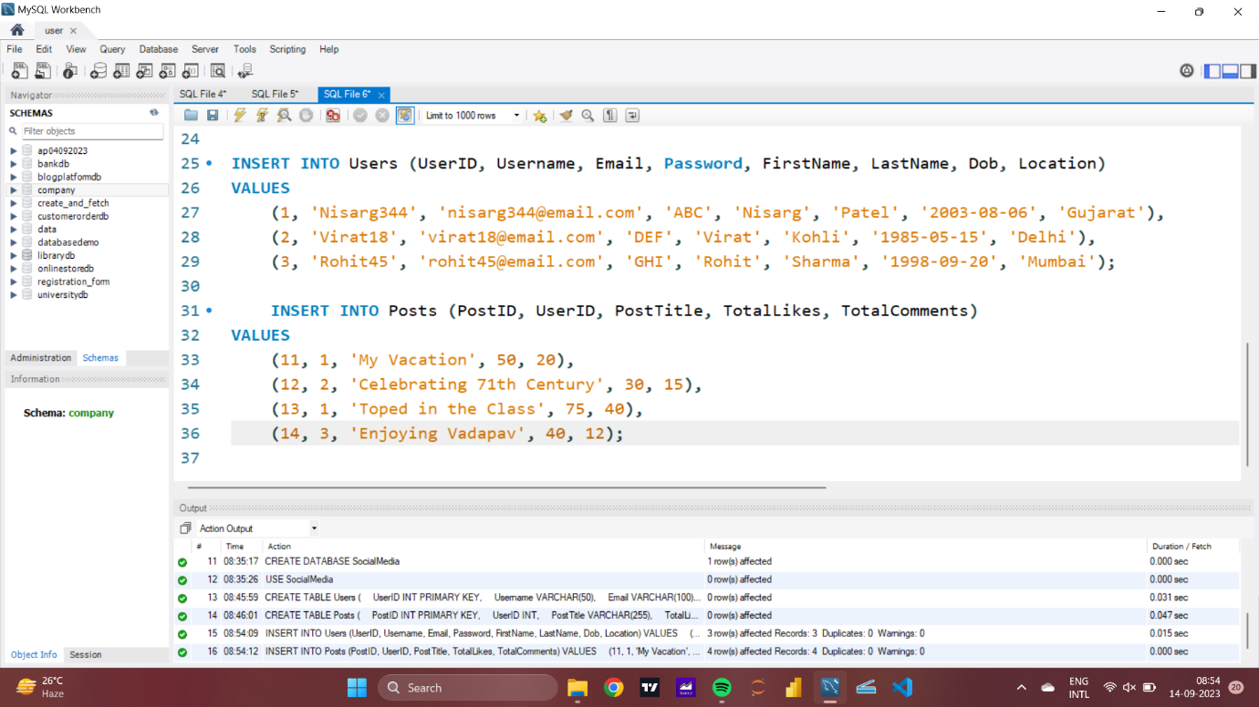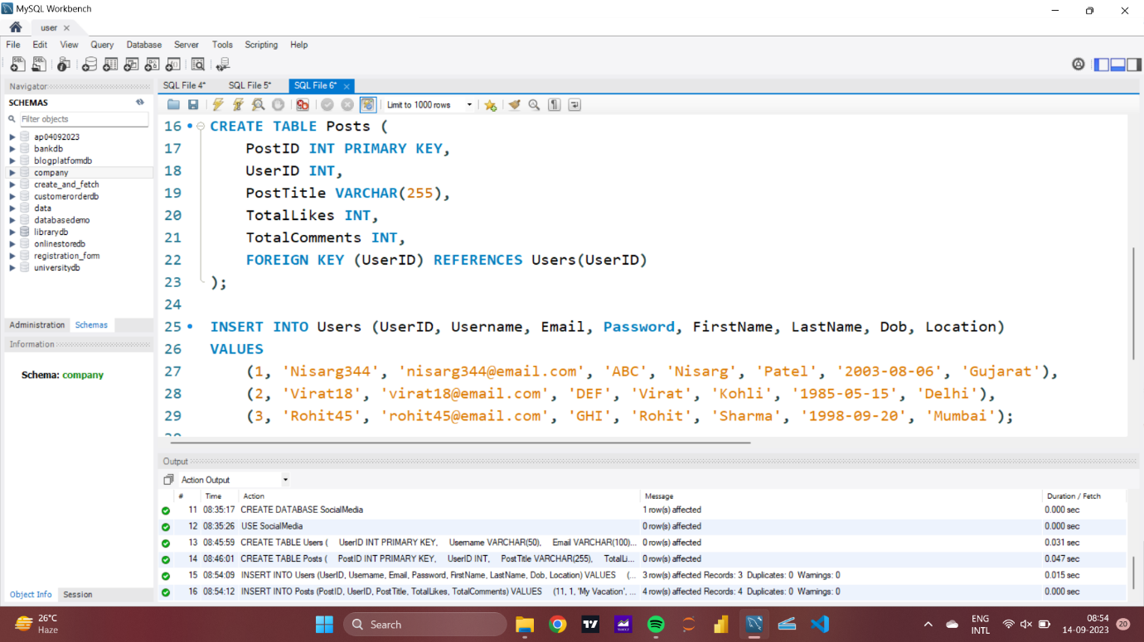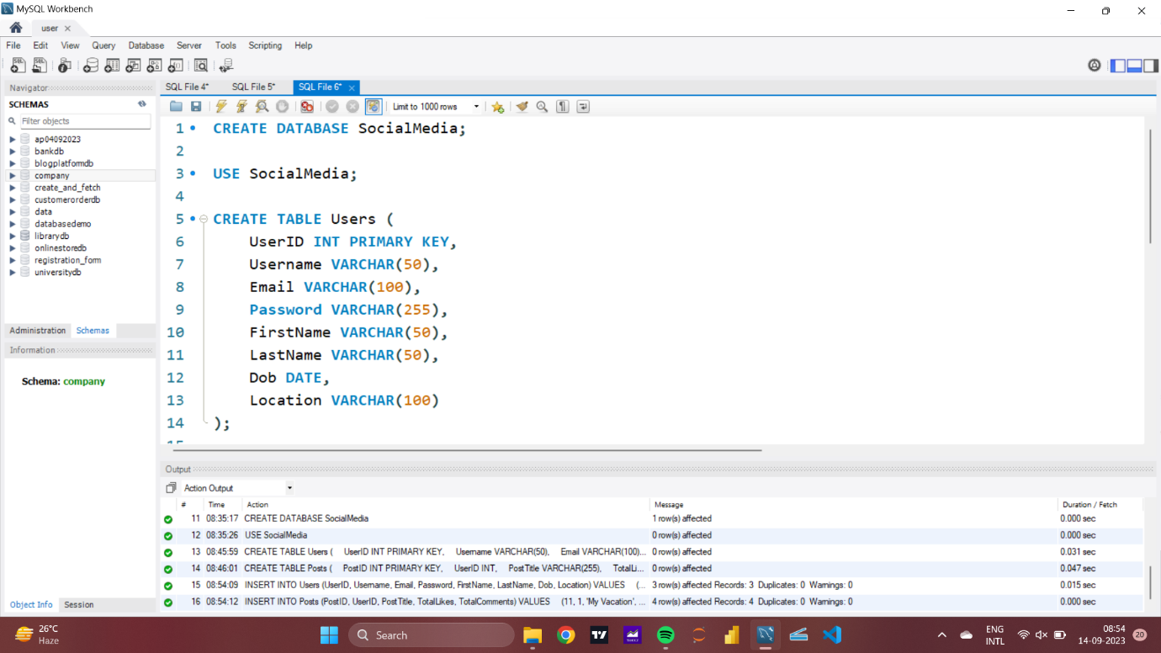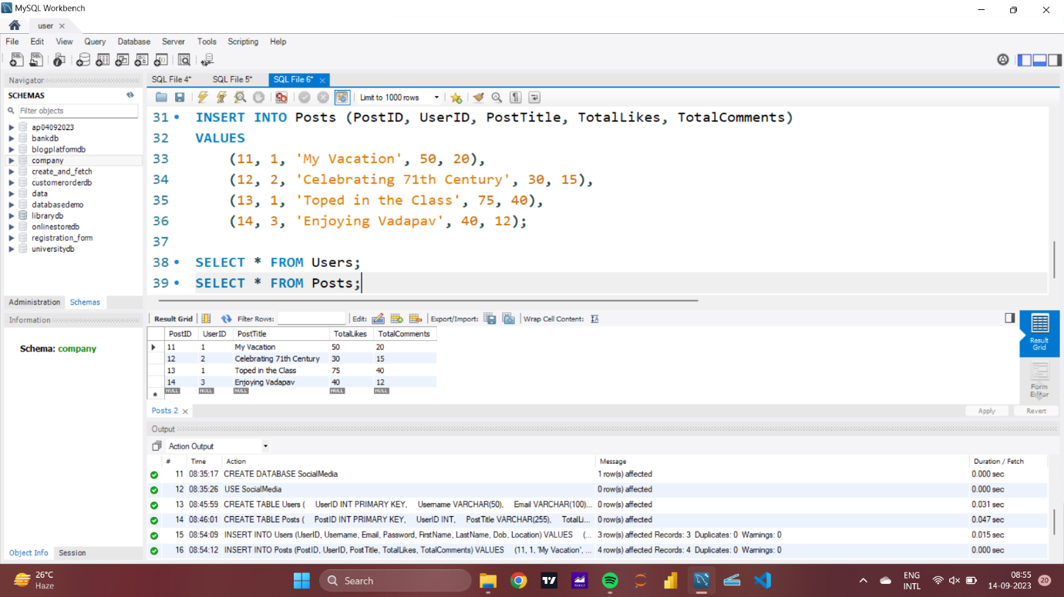

QUESTION 7